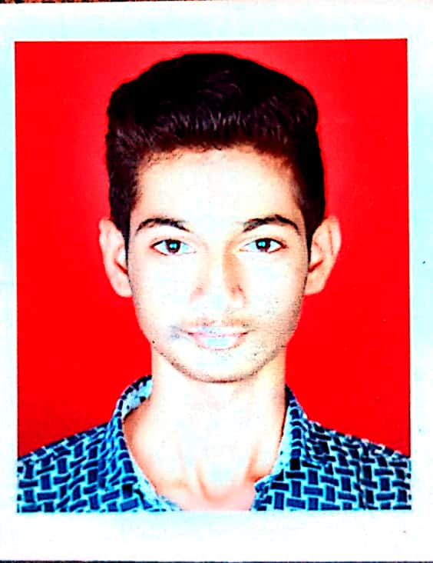**Harish Ramesh Rathod**

**Mobile**  : 9146698128

**Email Id** : rathodharsh395@gmail.com

**Linkedin** : https://www.linkedin.com/in/harish-rathod-48a177250/

**CAREER OBJECTIVE**

Seeking a Java Developer role where I can apply my programming skills and knowledge to develop innovative solutions.

**ACADEMIC BACKGROUND**

|  |  |  |  |
| --- | --- | --- | --- |
| Qualification | Institution | Year of Pass | Score |
| B.Sc. Computer Science | Phulsing Naik Mahavidhyalay. UNIVERSITY: Sant Gadge Baba University Amravati. | 2022 | 66% |
| 12th Class | Abasaheb Garvare Collage | 2019 | 54% |
| 10th Class | Shri Sivaji High School | 2017 | 86% |

**KEY SKILLS**

* **BACK END :** Java 8 , OOPs, String Handling, Exception Handling, Multithreading, JDBC, Servlet & JSP.
* **FRAMEWORDKS:** Collection, Spring Core, Hibernate.
* **FRONT END:** HTML, CSS, JavaScript.
* **DATABASE:** MySQL.
* **VCS:**  Git with GithHub.
* **TOOLS:** Lombok, IntelliJ & Eclipse IDEA, MySQL Workbench, VS Code.

**CERTIFICATION**

* Certified Java Developer From The Kiran Academy.

**INTERNSHIPS**

* **Company Name:** Pisyst India Pvt. Ltd. Pune.
* **Job Title :** Full Stack Developer Intern.
* **Work Experience** : 10 July to 7 Sep 2023 .
* **Key Responsibilities** : 1.Code reviewing with seniors 2.Making fronted (web-app) more responsive.

3.Debugging and taking feedback of tester. 4.Resolving Merge Conflict.

5.Discussing and implementing new features. 6.Any other task assignment by team lead.

**PROJECTS**

1. **Contract Farming** : Project consists a web application for admin, subadmin, team co-ordinator and a mobile application for farmer. Used Technologies: PHP(codeigniter), Xampp, HTML, CSS, JavaScript, Bootstrap. Worked on Responsiveness and Authentication, Authorization, Permissions of web application.
2. **Tic-Tac-Toe Game (live)**: <https://rathodharsh395.github.io/Tic-Tac-Toe/>

**PERSONAL DETAILS**

**Date of Birth** : 20/04/ 2001.

**Languages Known** : English, Hindi & Marathi.

**Hobbies** : Listening to music, watching and playing cricket.

**DECLARATION**

I hereby declare that all the information furnished above is true to the best of my belief.